**# 1What Is The Solar System?**

The Solar System is made up of all the planets that orbit our Sun. The Solar System also consists of moons, comets, asteroids, minor planets, dust, and gas.

Everything in the Solar System orbits, or revolves, around the Sun. Because the Sun is so large, its powerful gravity attracts all the other objects in the Solar System towards it. At the same time, these objects, which are moving very rapidly, try to fly away from the Sun, outward into outer space. The result of the planets trying to fly away is that they become trapped half-way in between. Balanced between flying towards the Sun, and escaping into space, they spend eternity orbiting around their parent star.

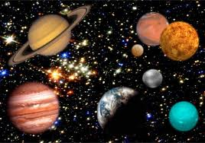

1. Which of these is NOT part of the Solar System?

○ asteroids

○ comets

○ satellites

○ planets

1. Why are objects in the Solar System attracted to the Sun?

○ It is so small, the other planets can come closer without burning.

○ It is so large, it’s gravity attracts everything in the Solar System.

○ The Sun is a large planet and is bigger than everything else.

○ No one knows why the Sun attracts so many things.

1. **Open Response:** Explain why the planets and other objects in the Solar System will forever be orbiting the Sun. Use evidence from the passage to support your answer.

**The Solar System**

|  |
| --- |
| **READING OPEN-RESPONSE ITEM A** |

1. In this passage, you learn about our Solar System. The author describes how the planets orbit. Why do objects spend eternity orbiting around the Sun? List four objects that orbit around the sun. Be sure to label your answers #1 and #2.

|  |
| --- |
| **A**  **________________________________________________________________________________________________________________________________________________________________________________________________________________________________________________________________________________________________________________________________________________________________________________________________________________**  **________________________________________________________________________________________________________________________________________________________________________________________________________________________________________________________________________________________________________________________________________________________________________________________________________________**  **________________________________________________________________________________________________________________________________________________________________________________________________________________________________________________________________________________________________________________________________________________________________________________________________________________**  **________________________________________________________________________________________________________________________________________________________________________________________________________________________________________________** |

|  |  |
| --- | --- |
| **Score** | **Description** |
| **4** | 1. Gravity pulls the objects (planets) towards the sun. As they try to fly away, the gravity pulls them in. 2. Moons, comets, asteroids, minor planets, dust and gas. (only need 4) |
| **3** | Student gives explanation of gravity and only 3 items that orbit the sun. |
| **2** | Student shows some understanding of why the planets orbit the sun and only list 2 items that orbit around the sun. |
| **1** | Student does NOT show understanding of why planets orbit but list at least 1 item that orbit around the sun. |
| **0** | The response is totally incorrect or irrelevant. There is no evidence that the student understanding of the setting. |
| **B** | Blank—No Response. (No attempt to answer the item. Score of “0” assigned for the item.) |

|  |
| --- |
| **RUBRIC FOR READING OPEN RESPONSE A** |

1. Rewrite the question here.

#2 Saturn

Do you have a favorite planet? Which one is it? It might be the gas giant Jupiter, or it could be red, rocky Mars. If your favorite is Saturn, however, then you are in for a treat as we’re going to have a look at this planet - but rather than talking about this gaseous world as a whole, we’re going to focus on one of its very important and most obvious features - its rings. These unusual features, which circle the planet like hula hoops, might be the reason why it’s your favorite - they certainly make Saturn stand out from the crowd and they are also very beautiful. Some astronomers say that it makes Saturn look like it has ears - at least, depending on what angle the rings are tilted towards the Earth - maybe you disagree and think that Saturn looks like a cup with two handles on either side!

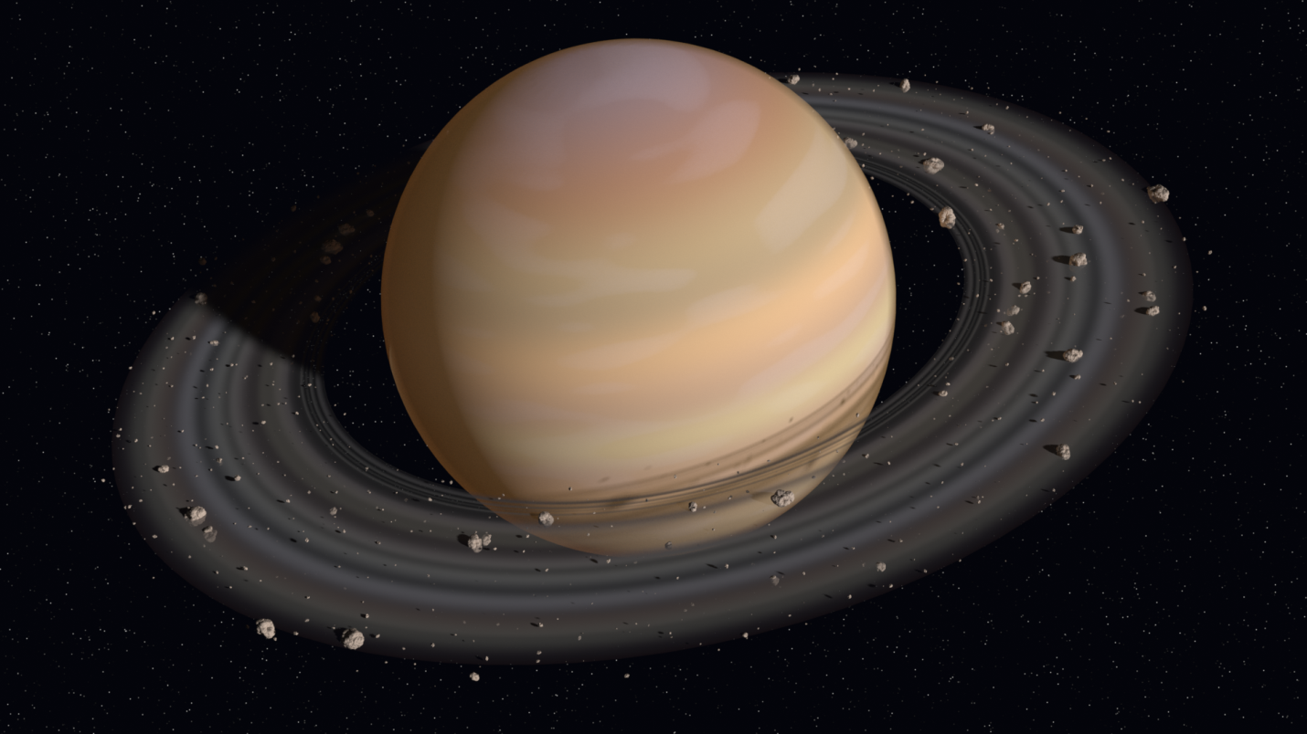

**Saturn**

|  |
| --- |
| **READING OPEN-RESPONSE ITEM A** |

1. What is the unusual feature of Saturn that is discussed in this passage? List 3 different ways the author described this feature.

|  |
| --- |
| **A**  **________________________________________________________________________________________________________________________________________________________________________________________________________________________________________________________________________________________________________________________________________________________________________________________________________________**  **________________________________________________________________________________________________________________________________________________________________________________________________________________________________________________________________________________________________________________________________________________________________________________________________________________**  **________________________________________________________________________________________________________________________________________________________________________________________________________________________________________________________________________________________________________________________________________________________________________________________________________________**  **________________________________________________________________________________________________________________________________________________________________________________________________________________________________________________** |

|  |  |
| --- | --- |
| **Score** | **Description** |
| **4** | 1. It has rings 2. The rings are like hula hoops, very beautiful, looks like it has ears or even a cup |
| **3** | Student states the feature and lists 2 ways it is described. |
| **2** | Student states the feature and only lists 1 way it is described. |
| **1** | Student states the feature and doesn’t give examples of how it is described. |
| **0** | The response is totally incorrect or irrelevant. There is no evidence that the student understanding of the passage. |
| **B** | Blank—No Response. (No attempt to answer the item. Score of “0” assigned for the item.) |

|  |
| --- |
| **RUBRIC FOR READING OPEN RESPONSE A** |

1. Rewrite the question here.

**#3 What are comets?**  
A comet is a small world which scientists sometimes call a planetesimal. They are made out of dust and ice, kind of like a dirty snow ball.

Many people think that a comet's tail is always following behind it, but actually the coma, or tail, can either be behind the comet **or** in front of it. Which way the tail is pointing depends on where the Sun is. That's right, the Sun's heat and radiation produce a wind called the *Solar Wind*, as a comet gets close to the Sun it begins to melt. The gas and dust that melt off are blown away from the Sun by the solar winds. So if a comet is traveling towards the Sun then the tail will follow behind, but if the comet is traveling away from the Sun the tail will be in front of the comet.

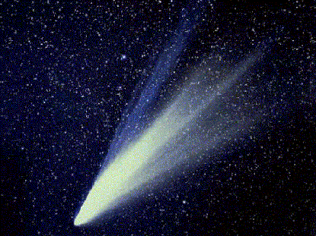

1. The author states that the comet is made of dirt and ice “like a dirty snowball.” This statement is an example of which literary device?

○ Hyperbole

○ Metaphor

○ Idiom

○ Simile

1. Another name for a comet’s tail is:

○ a coma

○ a planetesimal

○ a solar wind

○ a carol

1. The tail can be behind **or** in front of a comet depending on:

○ how many miles the comet is from the Sun

○ how far the comet is from a warm planet

○ whether the comet is traveling away from or toward the Sun

○ how much ice and dirt is in the comet

1. **Open Response:** Explain how a comet’s tail is formed. Use evidence from the text to support your answer.

**What are Comets?**

|  |
| --- |
| **READING OPEN-RESPONSE ITEM A** |

This passage teaches you about comets in our Solar System.

1. List 4 facts about comets. If a comet is traveling away from the Sun, where will the tail be located? Why does this happen? Be sure to label your answers #1, #2, and #3.

|  |
| --- |
| **A**  **________________________________________________________________________________________________________________________________________________________________________________________________________________________________________________________________________________________________________________________________________________________________________________________________________________**  **________________________________________________________________________________________________________________________________________________________________________________________________________________________________________________________________________________________________________________________________________________________________________________________________________________**  **________________________________________________________________________________________________________________________________________________________________________________________________________________________________________________________________________________________________________________________________________________________________________________________________________________**  **________________________________________________________________________________________________________________________________________________________________________________________________________________________________________________** |

|  |  |
| --- | --- |
| **Score** | **Description** |
| **4** | 1. Made of dust, ice, tail is the coma, tail travels in front or behind it, if the comet gets too close to the sun, it melts. 2. The tail would be in front of it. 3. This happens because the Sun’s heat begins to melt the comet and makes the Solar Wind, which blows away from the sun. |
| **3** | Student lists 3 facts; lists the correct location of tail; partly explains why the tail is in front. |
| **2** | Student lists 2 facts, the correct location of the tail, but not why the tail is located in front. |
| **1** | Student lists 1 fact about the comet, doesn’t know location of tail or why it is located in front. |
| **0** | The response is totally incorrect or irrelevant. There is no evidence that the student understanding of the passage. |
| **B** | Blank—No Response. (No attempt to answer the item. Score of “0” assigned for the item.) |

|  |
| --- |
| **RUBRIC FOR READING OPEN RESPONSE A** |

1. Rewrite the question here.

**#4 Earth**

Do you know where you live? With the hustle and bustle of everyday life, it is easy to forget that the human family lives on a small blue planet named Earth. All around us we see trees, animals, cars, buildings, farms, factories, stores, and other natural and man-made structures.

With all of these every day familiar objects around us and with the vast sky above us, and the deep oceans beneath us, our home planet often feels quite large. Compared to us, it is very large. There is enough space for each of us, our families and friends, our pets, as well as trillions of other life forms to live and enjoy the various experiences of life.

While to us, the Earth appears to be a vast wilderness, compared to other objects in the Universe it is actually quite small, in fact, it is so small, that you could say it is tiny.

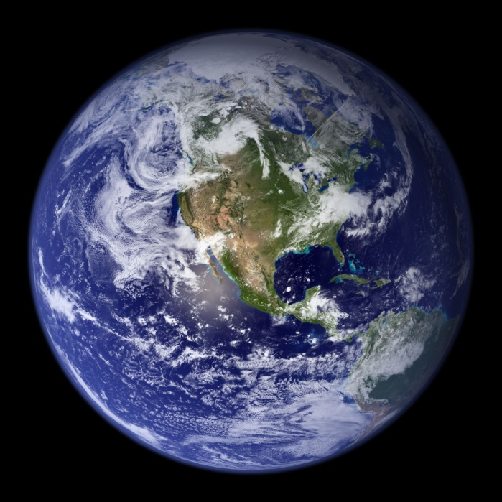

**Earth (opinion)**

|  |
| --- |
| **READING OPEN-RESPONSE ITEM A** |

1. The author states that the Earth “ is actually quite small, in fact, it is so small, that you could say it is tiny”. Using information from the passage, do you agree with this statement? (that Earth is tiny)

|  |
| --- |
| **A**  **________________________________________________________________________________________________________________________________________________________________________________________________________________________________________________________________________________________________________________________________________________________________________________________________________________**  **________________________________________________________________________________________________________________________________________________________________________________________________________________________________________________________________________________________________________________________________________________________________________________________________________________**  **________________________________________________________________________________________________________________________________________________________________________________________________________________________________________________________________________________________________________________________________________________________________________________________________________________**  **________________________________________________________________________________________________________________________________________________________________________________________________________________________________________________** |

|  |  |
| --- | --- |
| **Score** | **Description** |
| **4** | Student is able to use information from the passage to support his/her answer; giving viable reasons for their opinion. |
| **3** | Student gives opinion, but only uses some of the text to support his/her answer. |
| **2** | Student gives opinion but does not support it with information from the text. |
| **1** | Student gives facts from the passage but does not state his/her opinion. |
| **0** | The response is totally incorrect or irrelevant. There is no evidence that the student understanding of the question or passage. |
| **B** | Blank—No Response. (No attempt to answer the item. Score of “0” assigned for the item.) |

|  |
| --- |
| **RUBRIC FOR READING OPEN RESPONSE A** |

1. Rewrite the question here.

#5 How Big is the Earth?   
The Earth is the biggest of all the terrestrial planets. A terrestrial planet is a dense planet found in the inner Solar System. The diameter of Earth is 7,926 miles. The circumference measured around the equator is 24,901 miles. There are currently almost 7 billion people living on the Earth. About 30% of the Earth's surface is covered with land, while about 70% is covered by oceans.

Moons:   
The Earth has one moon.  Its name is Luna.

Scientists use the Earth to study all the other planets. Since no human has ever visited another planet, we have to use what we know about the Earth, and try to guess what the other planets must be like. This is called Comparative Planetology.

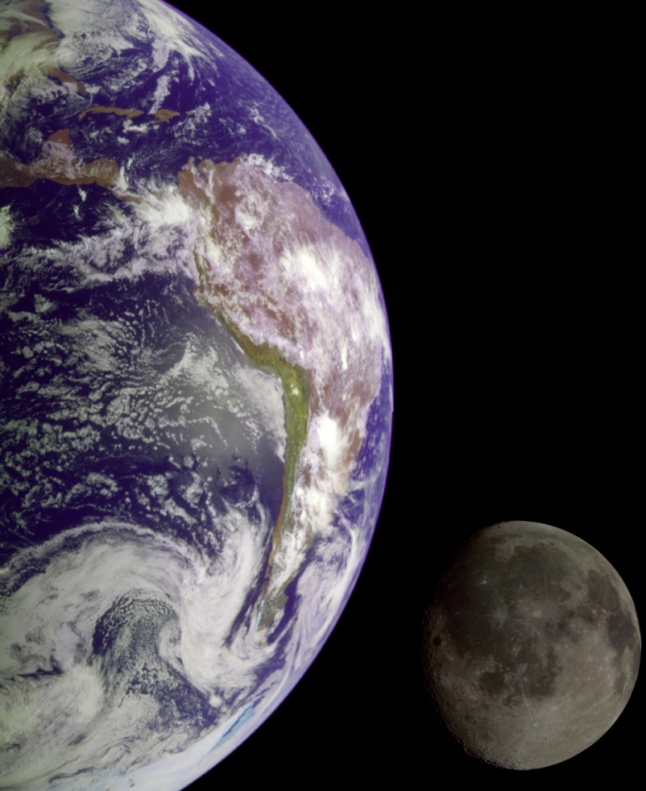

**How Big is Earth?**

|  |
| --- |
| **READING OPEN-RESPONSE ITEM A** |

1. This passage gives information about Earth. What is a terrestrial planet? Why do scientists study Earth and what is the name of this research? Be sure to label your answers #1, #2 and #3

|  |
| --- |
| **A**  **________________________________________________________________________________________________________________________________________________________________________________________________________________________________________________________________________________________________________________________________________________________________________________________________________________**  **________________________________________________________________________________________________________________________________________________________________________________________________________________________________________________________________________________________________________________________________________________________________________________________________________________**  **________________________________________________________________________________________________________________________________________________________________________________________________________________________________________________________________________________________________________________________________________________________________________________________________________________**  **________________________________________________________________________________________________________________________________________________________________________________________________________________________________________________** |

|  |  |
| --- | --- |
| **Score** | **Description** |
| **4** | #1 student gives definition of terrestrial planet (dense planet found in inner Solar System)  #2 Scientists study earth so they can learn more about other planets.  #3 Comparative Planetology. |
| **3** | Student gives correct answers for 2 out of 3 questions. |
| **2** | Student is able to answer 1 out of 3 questions. |
| **1** | Student gives facts not relevant to the questions. |
| **0** | The response is totally incorrect or irrelevant. There is no evidence that the student understanding of the question or passage. |
| **B** | Blank—No Response. (No attempt to answer the item. Score of “0” assigned for the item.) |

|  |
| --- |
| **RUBRIC FOR READING OPEN RESPONSE A** |

1. Rewrite the question here.